Uniform Policy
* Every CEL ship requires Black button down shirts as day time uniform.
In order to adhere to cruise line standards please follow the below uniform and grooming expectations:
UNIFORMS-MEN  Uniform:  - Black button down dress shirt (Recommended- minimum 3 onboard)  - Black suit pants (Recommended-minimum 3 onboard)  - Black dress socks (Recommended-minimum 7 onboard)  - Closed toe black dress shoes  - Cruise line provided name badge  - Cruise Line provided PPD.  Evening:  - Black suit jacket (Recommended- minimum 3 onboard)  - White button down dress shirt (Recommended- minimum 3 onboard).  - Bring Black Tie  Specialist:  - Specialists must wear jacket and tie at all times | UNIFORMS-WOMEN  Uniform:  - Black button down dress shirt (Recommended-minimum 3 onboard)  - Black suit pants or knee length skirt that match jacket (Recommended- minimum 3 onboard)  - Flesh colored hosiery with skirts (Recommended-minimum 3 onboard)  - Black dress shoes (enclosed), without any opening at the heel or toe.  - Cruise line provided name badge  - Cruise Line provided PPD.  Evening:  - Black suit jacket (Recommended- minimum 3 onboard)  - White button down dress shirt (Recommended-minimum 3 onboard.  Specialist:  - Specialists must wear jacket and scarf/tie at all times
GROOMING STANDARDS – MEN  Always:  - Impeccable personal hygiene  - Hair clean and combed  - Hair color must be natural  - Clean-shaven  - Approved facial hair (cruise line discretion)  - One ring on each hand (no ring on index finger or thumb)  - Nails clean and trimmed  - Uniform clean, pressed and in good condition  - Uniform fit properly not too tight or too lose  - Shoes polished  Never:  - Hair over the collar  - Ponytails  - Piercings (facial)  - Long sideburns  - Chin tufts  - Rips or stains on uniforms  - Heavy cologne  - Offensive, visible tattoos  - Chewing gum  - Reflecting (mirrored) sunglasses | GROOMING STANDARDS - WOMEN  Always:  - Impeccable personal hygiene  - Hair neat and business-like  - Hair color must be natural  - Appropriate makeup  - One pair of earrings worn on lower part of lobe  - Light-colored nail polish  - One ring on each hand (no ring on index finger or thumb)  - Uniform clean and in good shape  - Uniform fit properly not too tight or too lose  - Shoes polished  - Heels are permitted but not mandatory and should be no higher than 2” and should be comfortable.  Never:  - Heavy perfume  - Heavy makeup  - Piercings (facial)  - Long nails  - Designs on nails  - Bright or patterned hose  - Rips or stains on uniforms  - Big jewelry  - Very high heels  - Offensive, visible tattoos  - Chewing gum  - Reflecting (mirrored) sunglasses
[Grab your reader’s attention with a great quote from the document or use this space to emphasize a key point. To place this text box anywhere on the page, just drag it.]
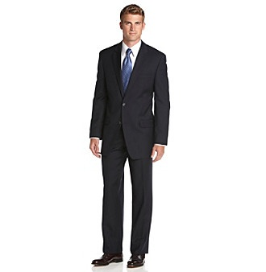
Slack pants and Appropriate Length Skirt
Date:
Acknowledged by:
Polished Closed Toe Shoes
No Bulky Jewelry
White Button up shirt
Pressed Suit
Natural Makeup
Styled Hair
Polished Shoes
Pressed Suit
Appropriate Tie
Clean Shaven
Fresh Haircut
Business Professional

